|  |
| --- |
| Department of Software Engineering  Mehran University of Engineering and Technology, Jamshoro |

|  |  |  |  |
| --- | --- | --- | --- |
| Course: SWE324 – Distributing Computing | | | |
| Instructor | Rabeea Jaffari | **Practical/Lab No.** | 08 |
| Date | 02 April 2019 | **CLOs** | CLO-4: P3 & P4 |
| Signature |  | **Assessment Score** | 1 Marks |

|  |  |
| --- | --- |
| Topic | To become Familiar with OLTP System Design |
| Objectives | * To learn XML schema and parsing an XML document. |

|  |
| --- |
| Lab Tasks |
| Submission Date: 09-04-19 |

4. Write an XML instance for following schema and then parse that document in Java using either DOM

or SAX API.

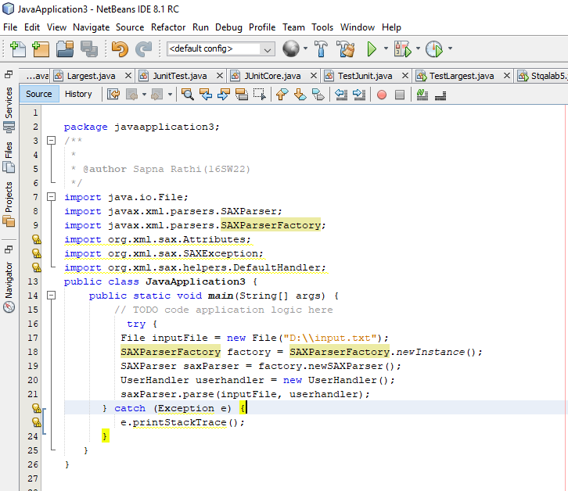

USerHandler Class

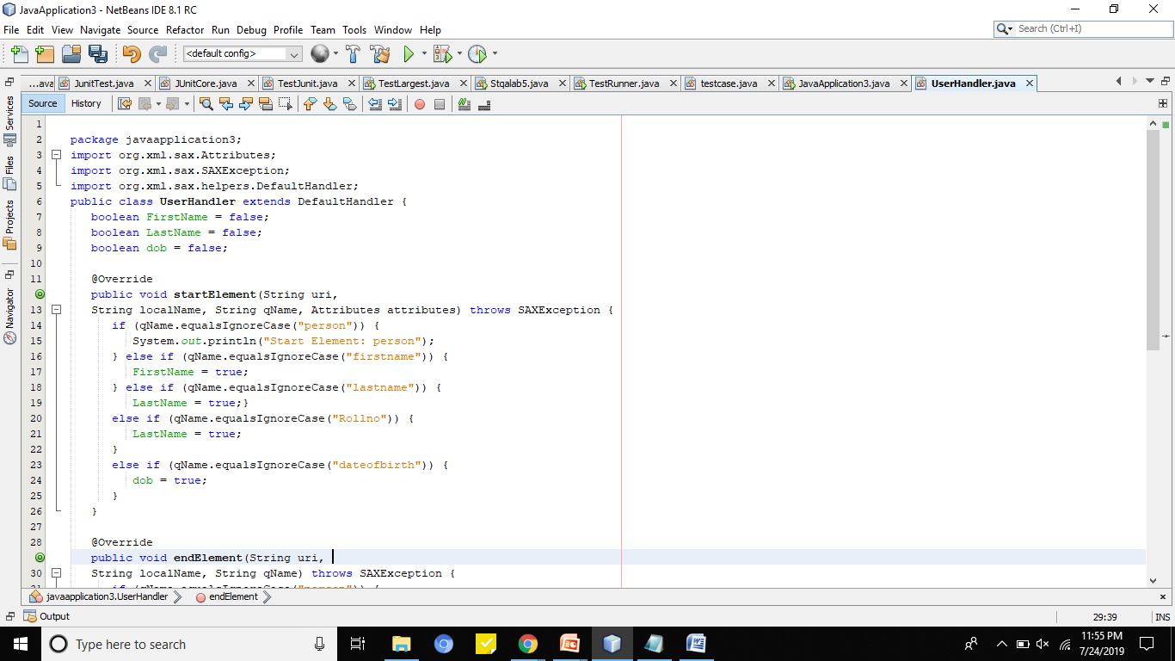

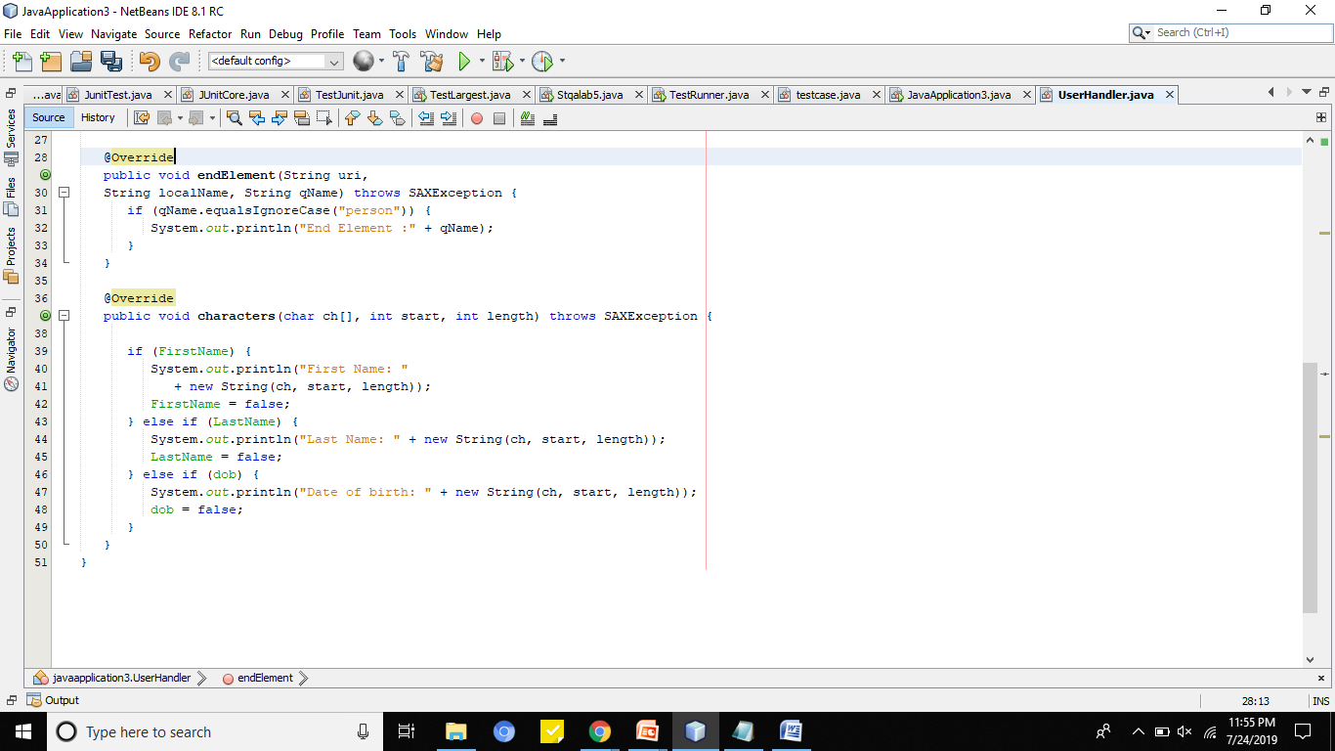

TextFile:

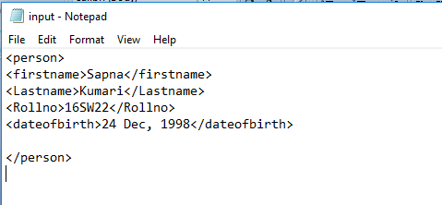

OUTPUT:

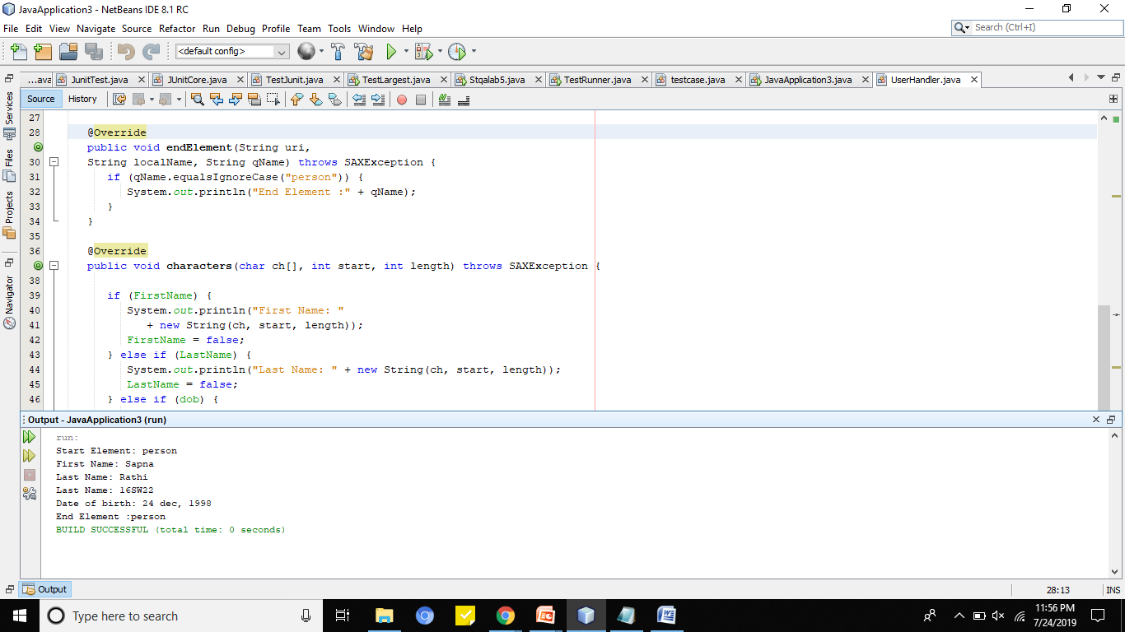

Lab task::

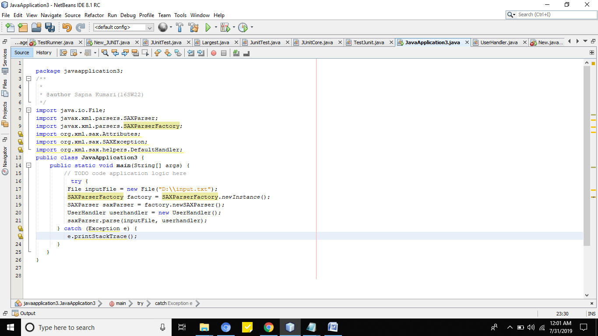

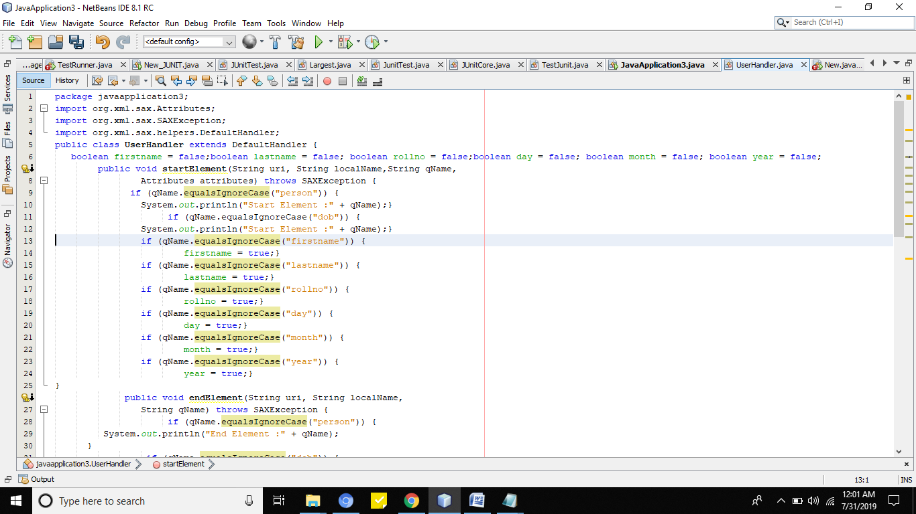

;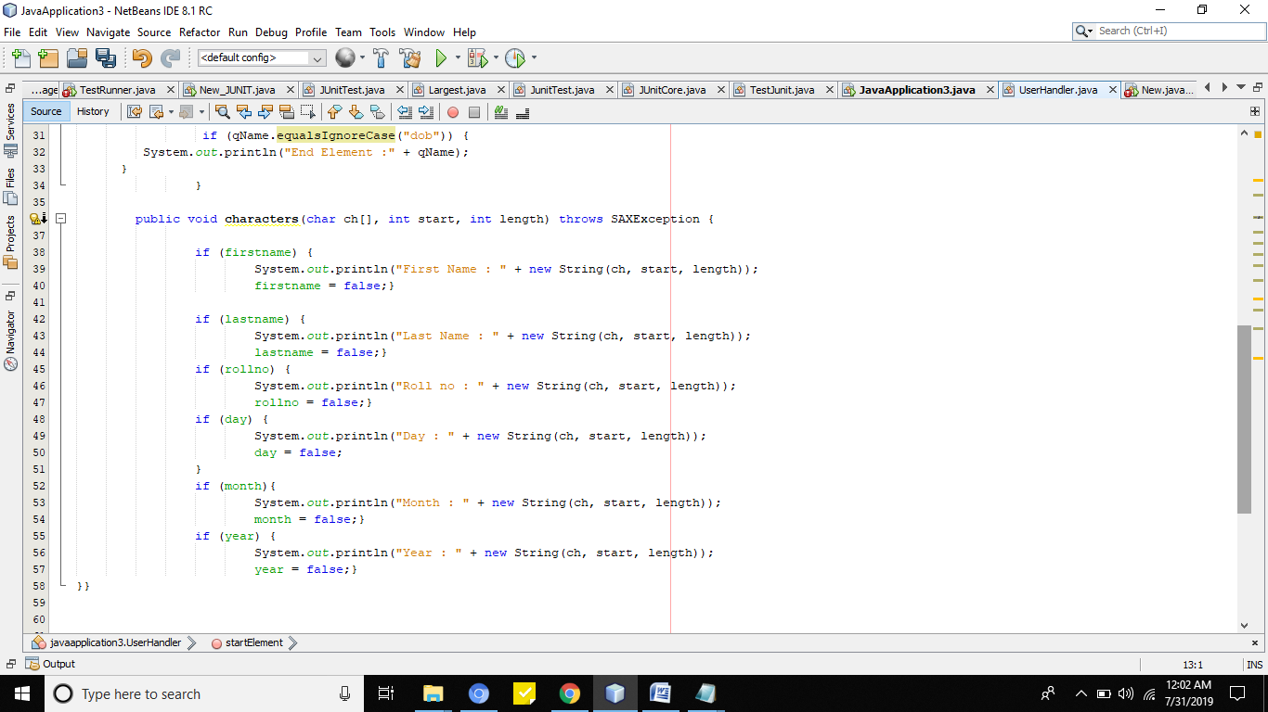

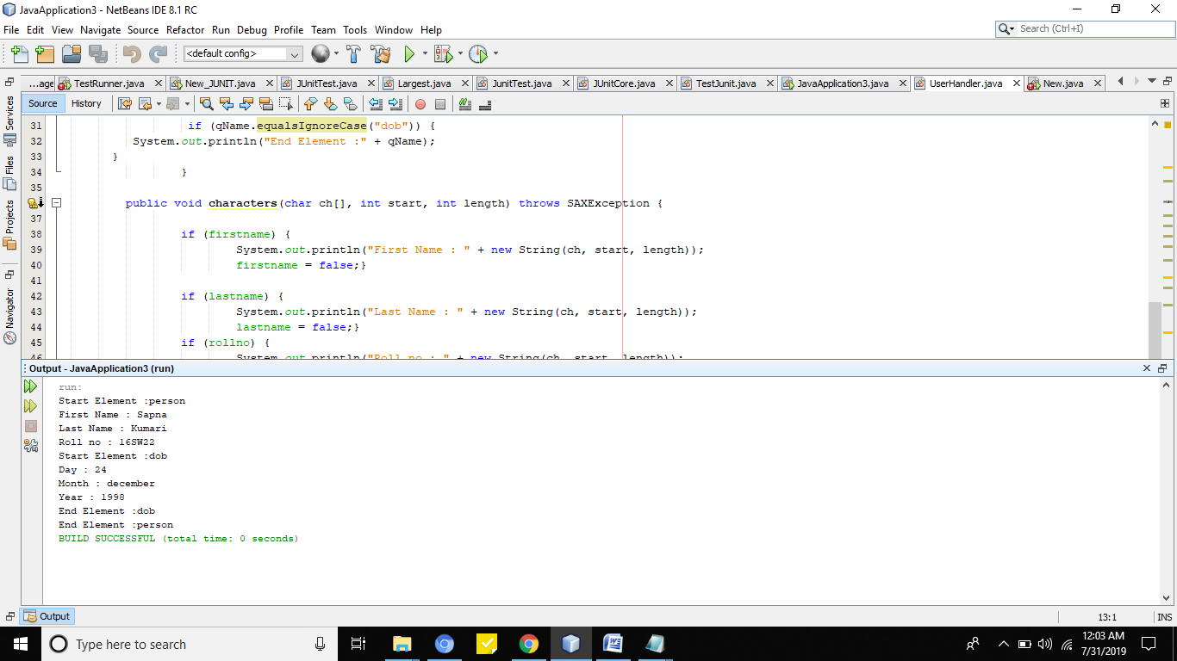

TextFile:

